COMP 3005 A3

Part 1

1. {BNAME | (exists SNAME, S, B)( Sailer( S, SNAME, _) and Boat(B, BNAME, _) and Reservation(S, B, _) and SNAME = ‘Bradley’)};
2. {SNAME | (exists B, S, SNAME) (Boat(B, ‘Paradise’, _) and Reservation(S, B, _) and Sailer(S,SNAME, _)};
3. {SNAME | (exists S)(Sailer(S, SNAME,_) and not Reservation(S,_,_)};
4. *{SNAME1, SNAME2 |( existsS, S1, B) )( Sailer( S, SNAME, _) and Boat(B, BNAME, _) and Reservation(S, B, _) and )};
5. {SNAME | (exists S)(Sailer(S, SNAME, _) and (forall B)(Boat(B,_, _) and Reservation(S, B, _))};
6. {SNAME | (exists S)(Sailer(S, SNAME, _) and (forall B)(exists BNAME)(Boat(B,BNAME, _) and ((BNAME = ‘Splendor’ and not (Reservation(S, B, _))) or (BNAME != ‘Splendor’ and Reservation(S,B, _)))};
7. {SNAME | (exists S, S’)(Sailer(S, ‘Bradley’, _) and Sailer(S’, SNAME, _) and SNAME != ‘Bradley’and (forall B)(Boat(B, _, _) and Reservation(S, B, _) and Reservation(S’, B, _) or not Reservation(S, B, _)))};
8. {SNAME | (exists S, S’)(Sailer(S, ‘Bradley’, _) and Sailer(S’, SNAME, _) and SNAME != ‘Bradley’and (forall B)(Boat(B, _, _) and Reservation(S, B, _) and Reservation(S’, B, _) or (not Reservation(S, B, _) and not Reservation(S’, B, _)))};
9. {SNAME, count(*) | (exists S)(Sailer(S, SNAME, _) and Reservation(S, _, _))};
10. T(SNAME, B) := {S, COUNT(*) | (exists S)(Sailer(S, SNAME, _) and Reservation(S, _, _))};

{S | (exists B)(T(S, B) and B > 2)};

Part 2

1. select Name from Boat B where exists (select * from Reservation R, Sailer S where S.Name = ‘Bradley’ and S.S# = R.S# and B.B# = R.B#);

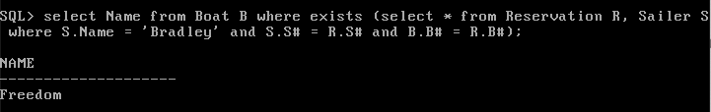

2. select Name from Sailer S where exists (select * from Reservation R where R.S# = S.S# and exists (select * from Boat B where B.B# = R.B# and B.Name = ‘Paradise’));

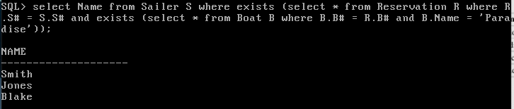

3. select Name from Sailer S where exists (select * from Reservation R where R.S# = S.S# and exists (select * from Boat B where B.B# = R.B# and B.Name in (‘Paradise’)));

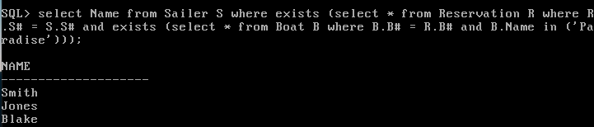

4. select S.Name from Sailer S, Boat B, Reservation R where S.S#=R.S# and B.B#=R.B# and B.Name=’Paradise’;

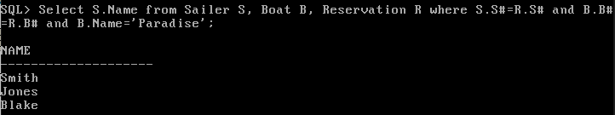

5. select S.Name from Sailer S where not exists (select * from Reservation R where S.S#=R.S#);

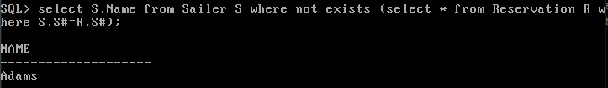

6. select Name from Boat B where exists (select * from Reservation R, Sailer S where S.Name=’Jones’ and S.S#=R.S# and B.B#=R.B#) minus select Name from Boat B where exists (select * from Reservation R, Sailer S where S.Name=’Bradley’ and S.S#=R.S# and B.B#=R.B#);

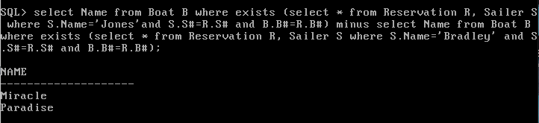

7.

8. select S.Name from Sailer S where not exists (select * from Boat B where not exists (select * from Reservation R where S.S#=R.S# and R.B#=B.B#));

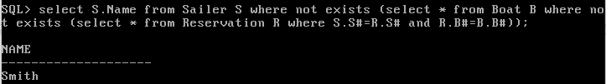

9. select S.Name from Sailer S where not exists (select * from Boat B where (B.Name != ‘Splendor’ or exists (select * from Reservation R where R.S#=S.S# and R.B#=B.B#)) and (B.Name=’Splendor’ or not exists (select * from Reservation R where R.S#=S.S# and R.B#=B.B#)));

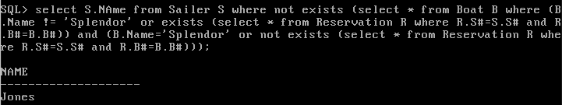

10. select s1.Name from Sailer S1, Sailer S where S1.Name != ‘Bradley’ and S.Name = ‘Bradley’ and not exists (select * from Boat B where exists (select * from Reservation R where R.B#=B.B# and R.S#=S.S#) and not exists (select * from Reservation R, Reservation R1 where S.S#=R.S# and B.B#=R.B# and S1.S#=R1.S# and B.B#=R1.B#));

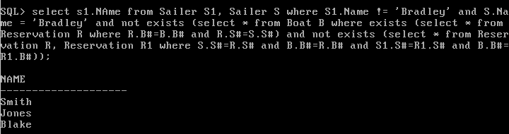

11. select S1.Name from Sailer S1, Sailer S where S1.Name != ‘Bradley’ and S.Name = ‘Bradley’ and not exists (select * from Boat B where not exists (select * from Reservation R, Reservation R1 where S.S#=R.S# and R.B#=B.B# and S1.S#=R1.S# and R1.B#=B.B#)

and exists

(select * from Reservation R where (S.S# = R.S# and R.B# = B.B#) or (S1.S#=R.S# and R.B# = B.B#)));

12. select Name, count(*) from Sailer natural Join Reservation group by Name;

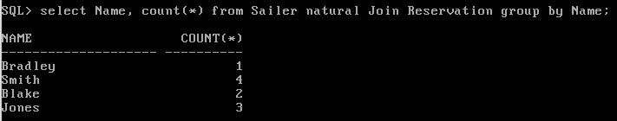

13. select distinct Name from Sailer S, Reservation R1, Reservation R2, Reservation R3 where S.S# = R1.S# and S.S# = R2.S# and S.S# =R3.S# and R1.B# != R2.B# and R1.B# != R3.B# and R2.B# != R3.B#;

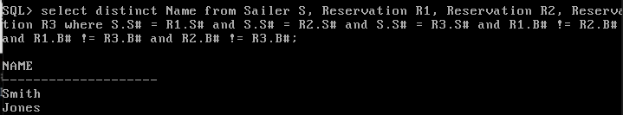

14. select Name from Sailer natural Join Reservation group by Name having count(*) > 2;

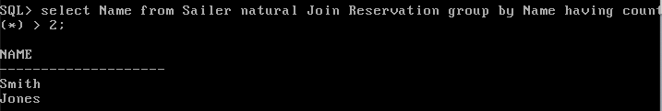

15. select * from Sailer full outer join Reservation using (S#) full outer join Boat using (B#);

*Not sure why its printing like this.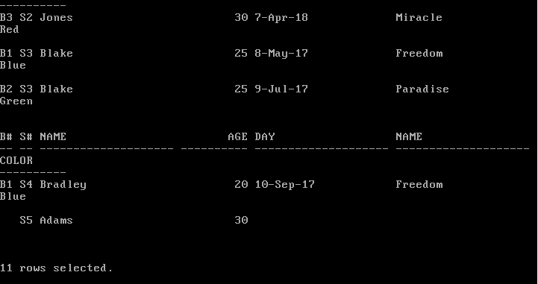

16. select Name, count(Day) from Reservation Natural full outer join Sailer group by Name;